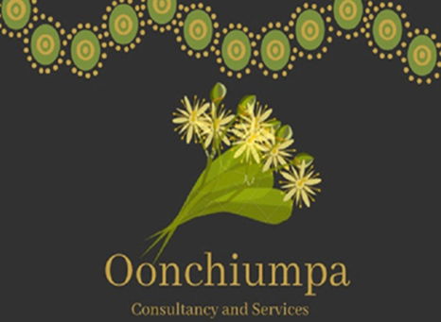

Oonchiumpa Consultancy and Services

24 Parsons Street

Alice Springs NT 0870

Phone: 0474 702 523

Email: [admin@oonchiumpaconsultancy.com.au](mailto:admin@oonchiumpaconsultancy.com.au)

***“Two Cultures, One World, Working Together”***

**Good News Story**

**Oonchiumpa Girls Day Out – Standly Chasm**

This trip allowed the girls July, Tyreena, Jonika and Henrisha enjoyed a girls day out on country. An opportunity to get out see the great work that other Aboriginal traditional owners are doing on their own land and making them feel empowered that they too can achieve the same goals.

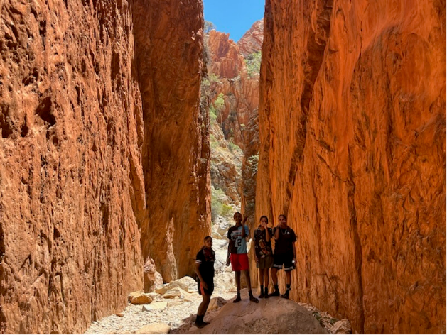This day was a very hot day, however it was a great opportunity for the girls to open up about how they are feeling.

